OFFICE ORDER FOR TRAVEL ACTIVITIES

No. <<TARF #>>, s. 2026

TO: <<Person/s to Travel (Position)>>

You are hereby <<Final Approval>> to travel to <<Destination/s>> on <<Date of Departure>> to <<Date of Return>> to attend/conduct the “<<Event to Attend/Purpose of Travel>>” .

You are authorized to conduct this travel on <<Type of Travel Requested>>.

Please be guided accordingly.

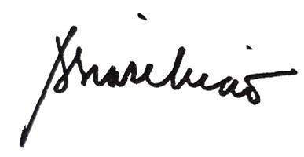

Amabel S. Liao, PhD
University President

